**Raplica Exercise**

**Question:**

1. Start MongoDB without authentication

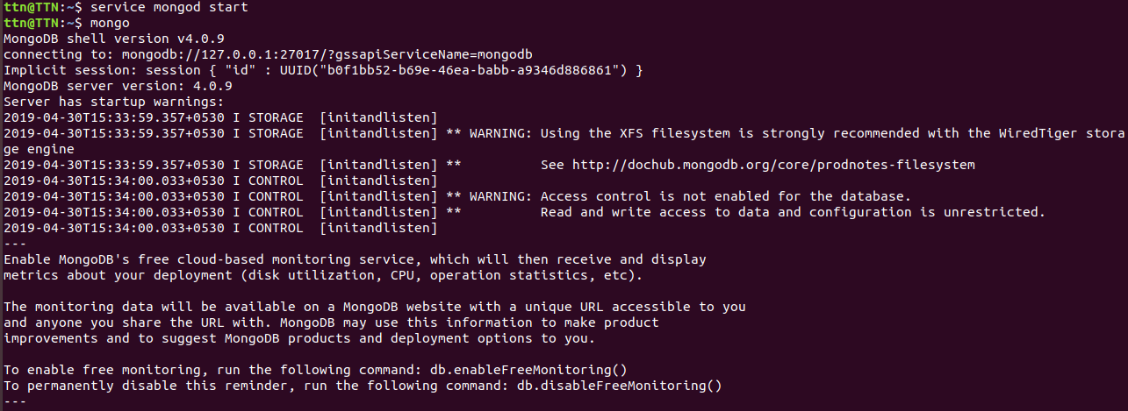

2. Create Database ttn and insert some data into user collection.

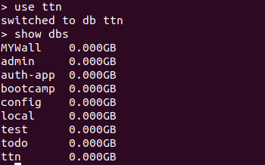

3. Setup the replication with Artiber and verify that ttn database is replicated into secondary.

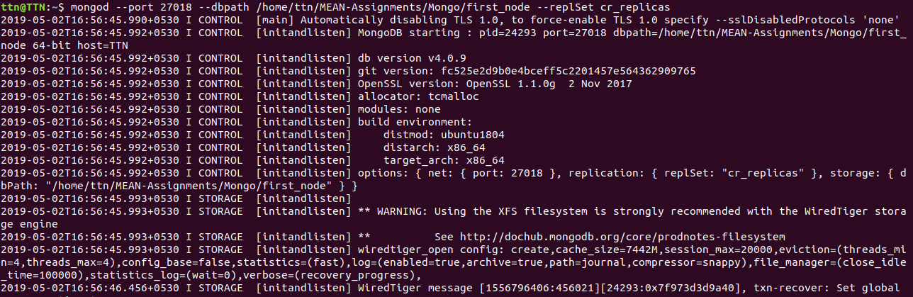

Created 2 more replicas

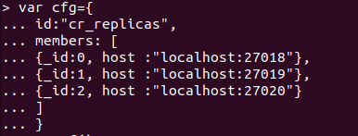

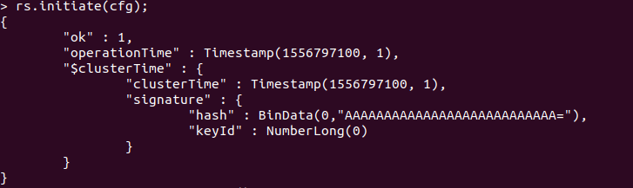

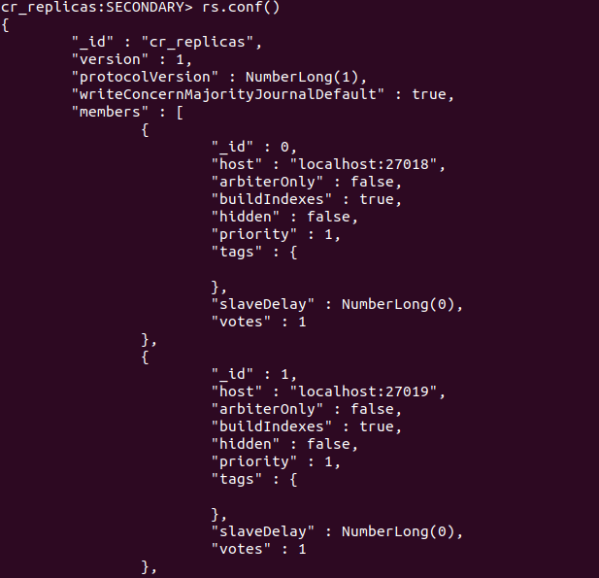

**Aggregation Exercise**

**Question 1:**

Add 50 User and 100 Address Collection, One User has multiple Address.

User properties - name, age, companyName, type, fatherName, motherName, Address ArrayIds as references.

Address Properties - houseNo, landmark, city, state, pincode.

Write a query for to fetch all address data from address in users. Limit should be 10 and skiping first five.

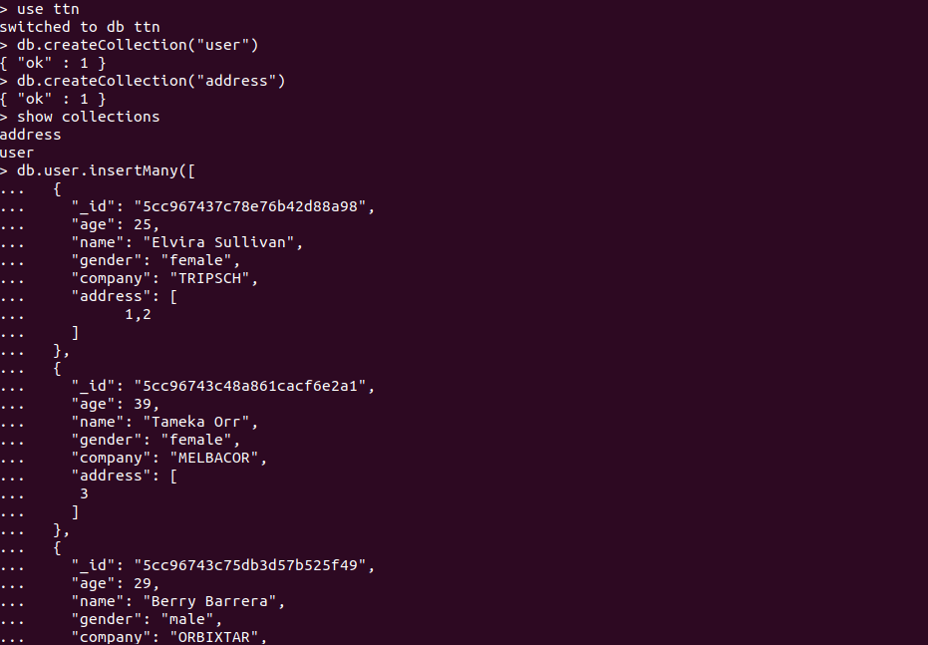

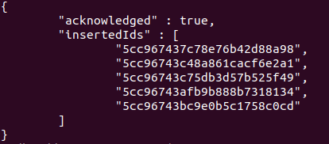

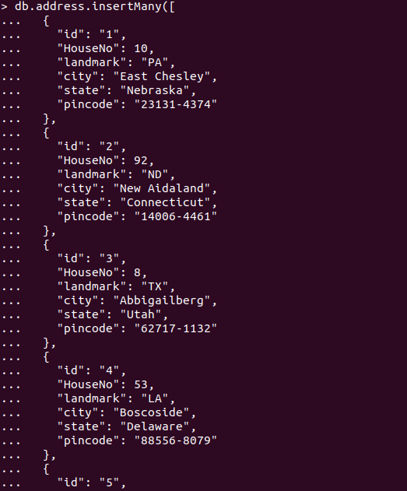

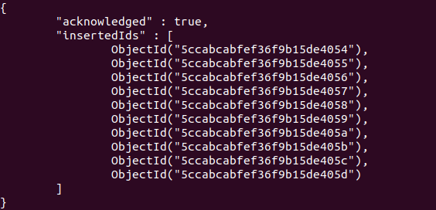

**Question 2:**

Fetch & Sort User data on base of user names, Sort Address cities in User table. Limit should be 5 and skipping first 2.

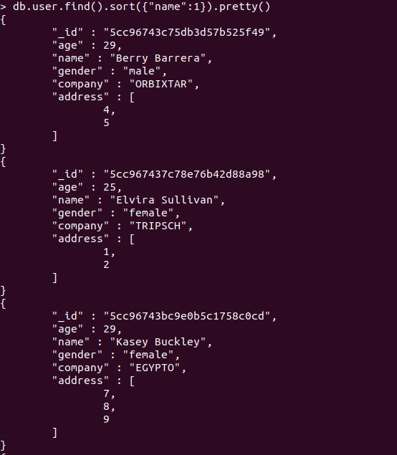

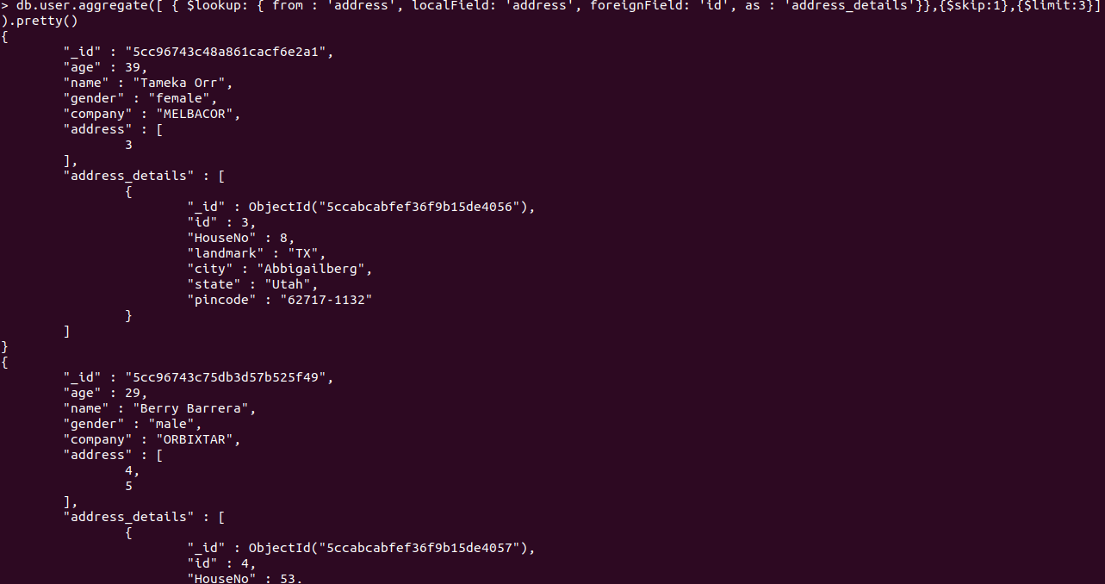

**Question 3:**

Fetch only address selective data (UserID:””, AddressData:”” ) from user table, keys should be like above.

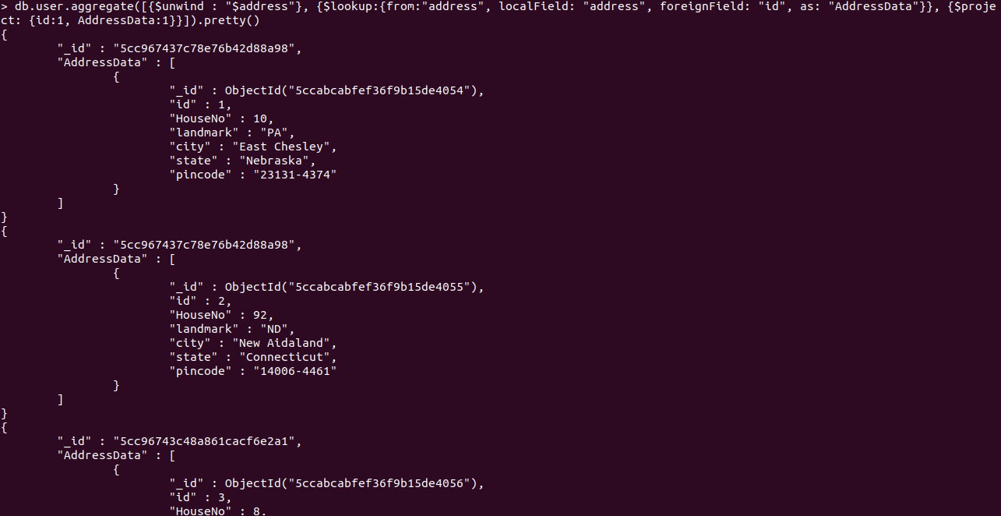

**Question 4:**

Create indexes in Address table, on city and state. And Sort it.

